**Exercise 8.4:**

**1.**

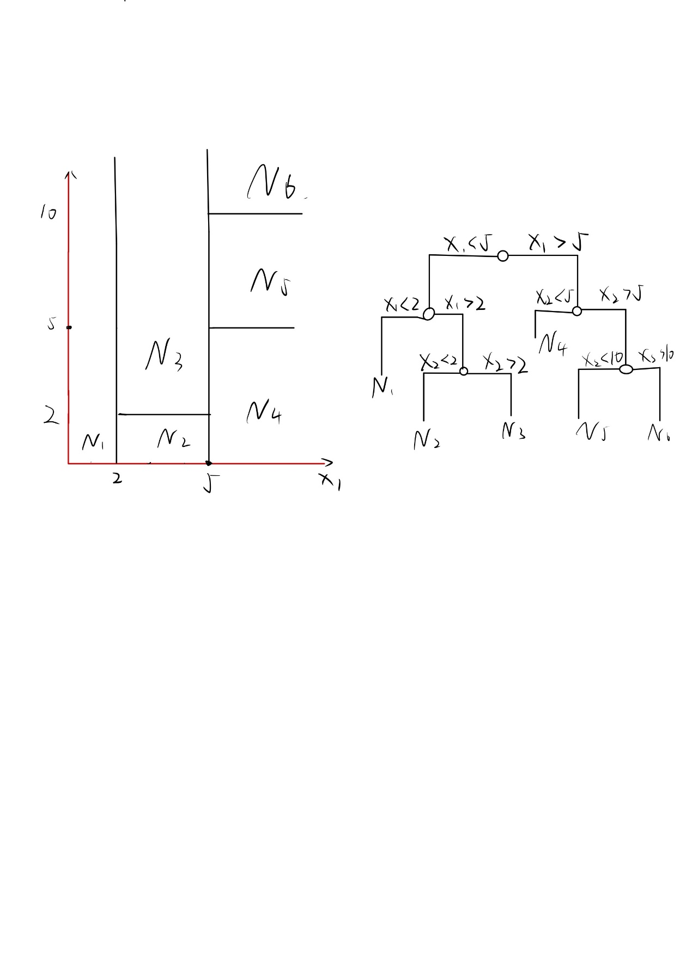

**2.**

In a setting with two classes, pmk is the proportion of observations of class k in region m. So, classification error E equals to

$$E= \left\{\begin{aligned}p_{mk}, 0≤p_{mk}≤0.5 \\ 1-p_{mk}, 0.5≤p_{mk}≤1\end{aligned}\right.$$

Gini index equals to

$$G=p_{m1}*\left(1-p_{m1}\right)+p_{m2}*\left(1-p_{m2}\right)$$

Cross entropy equals to

$$D= -p_{m1}*logp_{m1}-p_{m2}*logp_{m2}$$

The plot is like

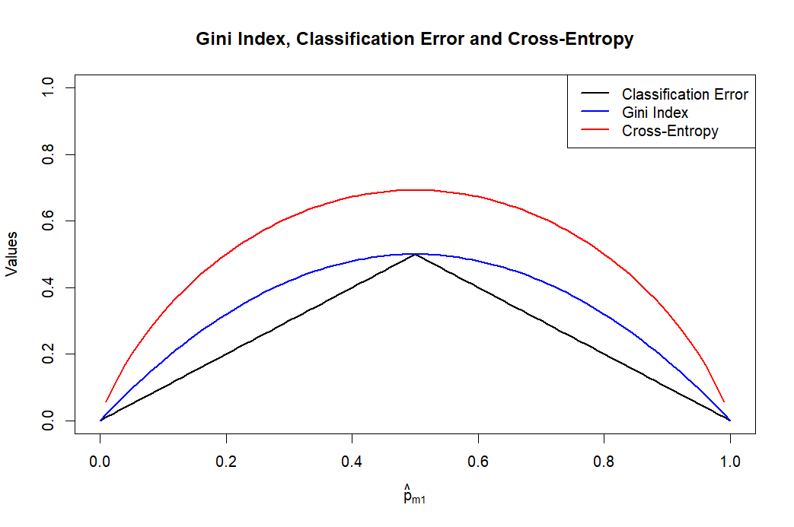

**3.**

